Balancing Act - Financial Dynamics and Consumption Patterns in Renewable vs. Fossil Fuel Energy

By

Hydrocarbon Research Group



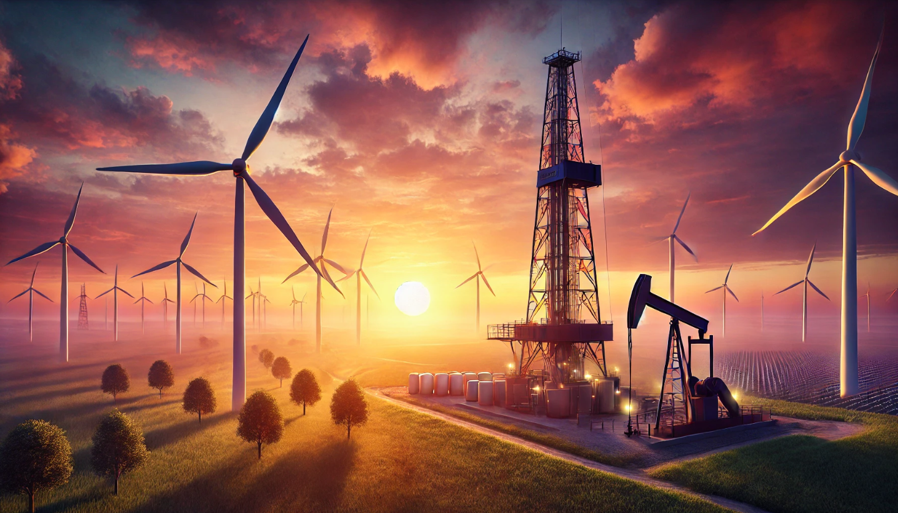

Summary

This report provides a detailed analysis of the different dynamics between renewable energy and fossil fuels among the major economies in the East and West regions of the world. It highlights trends, patterns, and projections of energy consumption and goals for both regions. The report also covers market dynamics by examining the differences in investment patterns between renewable and fossil fuel energy sectors. Additionally, it includes a composite overview of how four of the biggest companies in each energy sector allocate their spending and generate earnings, offering a micro comparison of financial strategies and operational focus. This analysis aims to provide insights into the evolving energy landscape and the implications for future sustainability and growth.

West Energy Consumption Comparion

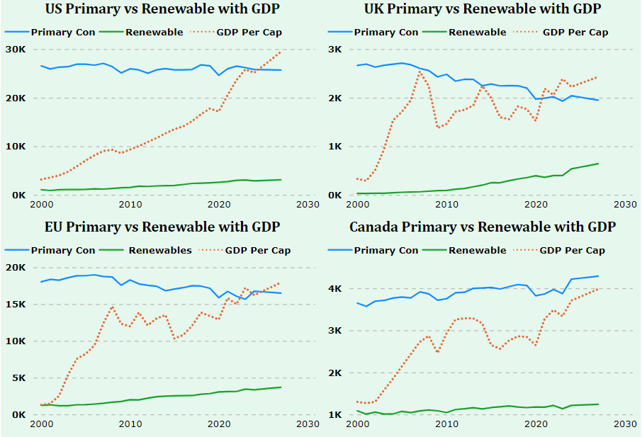
- Data - sourced from Ourworldindata
- Forecasting – All regions and categories were forecasted from 2023 to 2027. Point (middle) forecast projections were used for all categories and regions.
- Primary Energy Primary energy consists of raw fuels such as coal, crude oil, natural gas, uranium, and other resources directly extracted from the environment. For this chart we separated any renewables from coal, natural gas and crude.
- GDP Per Capita GDP per capita is calculated by dividing a country's total gross domestic product (GDP) by its population.
- Renewables In this data, renewables include hydroelectric power, solar, wind, and nuclear energy sources for each country.

Patterns and Insights

All four regions in the West show continued growth in GDP per capita, with the United States leading the way. Three regions have made attempts to close the gap between primary energy consumption and renewable energy consumption, with the UK outpacing the others. However, to achieve net zero and sustainable energy goals by 2035-2050, a significant shift is necessary.

Renewable Energy Gap -From 2017 to 2027, the average gap between primary energy and renewables for all four regions combined remains 80%. This means that even the world leaders in renewable energy progress are using, or will use, only approximately 20% of their energy from renewables, combined.

Regional Leader -The UK is leading the efforts to close the gap between primary energy consumption and renewable energy consumption, outpacing the other regions with a 10-year average around 78%.

Future Outlook - To achieve net zero and sustainable energy goals by 2030, a significant shift in energy consumption and production practices is necessary across all regions. Strong commitments and financial allocation towards these goals are in the works.

Renewable Goals and Commitments

The United States
The U.S. aims to achieve a carbon pollution-free power sector by 2035 and net-zero emissions by 2050. As of 2023, the current administration has allocated $1.8 trillion towards energy transition technologies and their supply chains, according to a report by BNEF. To support this transition, both private and government entities, including the Department of the Interior, Walmart, and Amazon, are actively facilitating the development and investment in renewable energy. These efforts encompass a range of initiatives, from modernizing infrastructure to accelerating the permitting process for renewable energy projects.

The United Kingdom-
The UK is committed to achieving net-zero emissions by 2050, supported by substantial investments in renewable energy and new technologies like CCUS, hydrogen, and small modular reactors. The government aims to unlock up to £90 billion in private investment by 2030. However, challenges such as regulatory hurdles, investment certainty, and technological integration remain. The UK continues to drive forward with strong public and private sector partnerships to meet its ambitious renewable energy goals​

The European Union
The EU aims to achieve climate neutrality by 2050, targeting a 42.5% share of renewable energy by 2030. Significant investments, including doubling solar photovoltaic capacity to 320 GW by 2025 and 600 GW by 2030, are planned under the REPowerEU plan to reduce dependence on Russian fossil fuels and accelerate renewable energy deployment​. Public and private sector collaborations and funds like the Trans-European Networks for Energy (TEN-E) support these initiatives​. Key infrastructure projects include modernizing the electricity grid and enhancing cross-border interconnections​.

Canada
Canada aims for net-zero emissions by 2050 and a 40-45% reduction in greenhouse gas emissions by 2030, with $60 billion allocated for clean energy investments over the next decade​. Key partnerships involve the Canada Electricity Advisory Council and private sector collaborations, which have attracted over $50 billion in investments​. Infrastructure efforts focus on doubling electricity generation capacity by 2050, emphasizing wind, solar, SMRs, and energy storage​.

East Energy Consumption Comparison

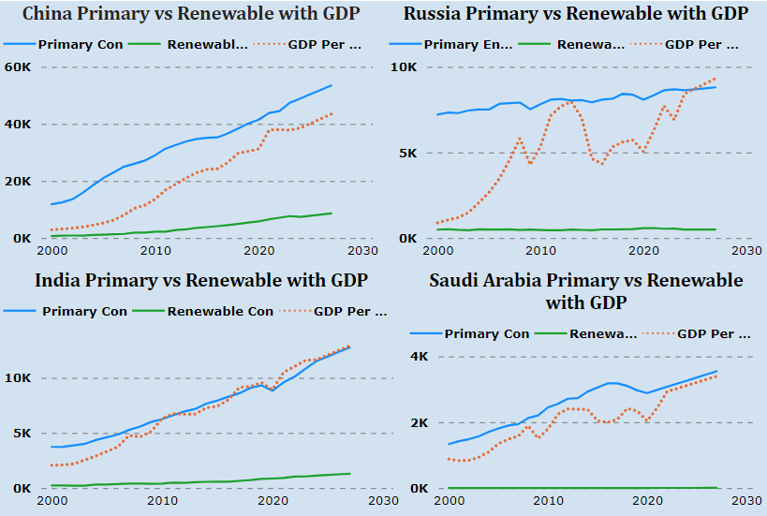

- Data - sourced from Ourworldindata
- Forecasting All regions and categories were forecasted from 2023 to 2027, except for Saudi Arabia, which was forecasted from 2021 to 2027 due to limited data. Slight subjectivity was applied to two regions and categories.
For India and Saudi Arabia's renewable energy forecasts, the upper confidence bound was used due to their rapid advancements in this sector. Point (middle) forecasting was used for all other categories and regions.
- Primary Energy Primary energy consists of raw fuels such as coal, crude oil, natural gas, uranium, and other resources directly extracted from the environment. For this chart we separated any renewables from coal, natural gas and crude.
- GDP Per Capita GDP per capita is calculated by dividing a country's total gross domestic product (GDP) by its population.
- Renewables In this data, renewables include hydroelectric power, solar, wind, and nuclear energy sources for each country.

Patterns and Insights

Clear patterns are emerging. Primary energy consumption continues to outpace renewables by significant margins, so much so, that none of the East regions surpassed 10% energy consumption using renewables. It's also notable that GDP is on an upward trajectory and more in sync with Primary Energy Consumption.

Renewable Energy Gap- The gap between primary energy consumption and renewable energy remains substantial. For Eastern regions combined, the average gap from 2017 to 2027 is 92%. This indicates that, on average, renewables account for only 8% of the primary energy needs in these regions.
Regional Leader- China stands out as the most improved in terms of renewable energy adoption among Eastern regions. It leads in both primary energy consumption and renewable energy capacity.

Future Outlook- The continued rise in GDP across all regions underscores the growing energy demand. Geopolitics and future policy will be the primary moves of growth for both types of energy going forward.

Renewable Goals and Commitments

Saudia Arabia
Saudia Arabia’s vision 2030 aims to diversify its economy and reduce its dependence on oil. The Kingdom plans to generate 50% of its energy from renewables by 2030. Saudia Arabia had almost a 300% increase in Renewable Energy consumption from 2020-2021
The NEOM Project. The $500 billion project includes plans for a 100% renewable energy-powered city. Saudi Arabia is investing heavily in solar and wind projects, including the 2.6 GW Al Shuaibah solar project and the Dumat Al Jandal wind farm, the largest in the Middle East.

India
India aims to achieve 450 GW of renewable energy capacity by 2030. The country has set Renewable Purchase Obligation (RPO) targets, which mandate a minimum share of renewable energy in total energy consumption, progressively increasing to 43.33% by 2029-30​
In 2023, India invested $68 billion in clean energy, nearly 40% higher than the average from 2016-2020. This investment is directed towards solar PV, wind, and other low-emissions power generation​ (IISD)​.

China
China invested approximately $890 billion in clean energy sectors in 2023, a 40% increase from 2022. This includes solar, wind, electric vehicles (EVs), energy storage, and grid infrastructure​ (Carbon Brief)​. Targets China aims to peak carbon emissions by 2030 and achieve carbon neutrality by 2060. The country is rapidly expanding its renewable energy capacity, with significant investments in solar and wind power​.

Russia
Russia’s energy sector is heavily reliant on fossil fuels, with renewables contributing a minor share.
Policies and Investments Russia has set modest targets for renewables and is investing in nuclear and hydropower. Wind and solar projects are being explored to diversify the energy mix and reduce carbon emissions​. Geopolitical issues are also playing a factor as mentioned above. Sanctions have impacted foreign investments in Russia’s renewable sector, slowing its progress.

Market Dynamics
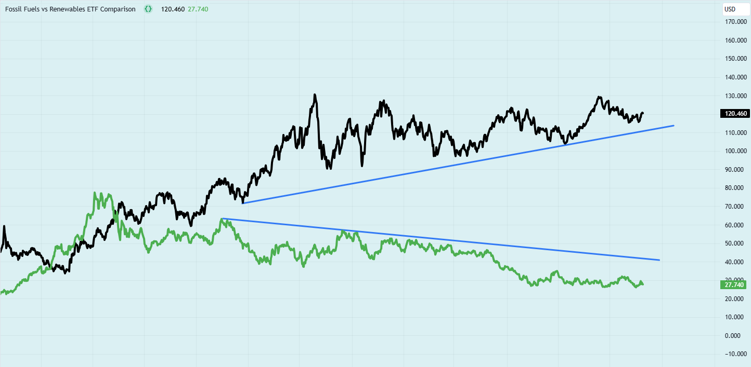

Fossil Fuel ETF’s Vs Renewable ETF’s
Data- Pine Script was created to compare two combined fossil fuel ETFs with two combined renewable energy ETFs. Specifically, the Energy Select Sector SPDR Fund was combined with the SPDR S&P Oil & Gas Exploration & Production ETF for the fossil fuel sector. For renewables, the iShares Global Clean Energy ETF was combined with the Invesco Solar ETF. The script uses the daily closing prices of these ETFs to calculate the average closing price for both the fossil fuel and renewable energy groups. This provides a clear comparison of investment exposure across both energy sectors.
Insights

- We observe a clear divergence between the two combined investment ETFs. The black line represents fossil fuels, while the green line represents renewables. This divergence started to become noticeable at the end of December 2021. Over the nearly three-year period that followed, the trend has consistently indicated a preference for investments in fossil fuel ETFs.
- Markets bring transparency to the overall energy landscape due to their inherent incentives. Money serves as a key driver and force multiplier to any given narrative. Achieving a specific path, agenda, or goal requires financial investments and capital allocation to be fully in sync. Without aligned financial support, it is challenging to realize these objectives completely. If the trajectory of these two data points continue what signal does this send to those in the camp of net zero and renewable energy ambitions?

Renewable Energy and Oil & Gas Costs and Expenses
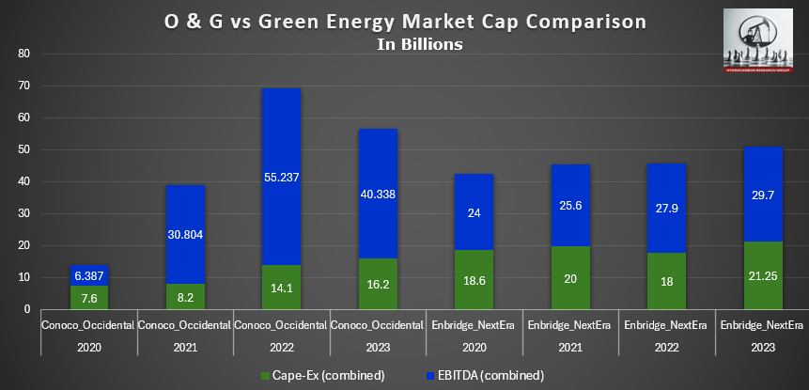
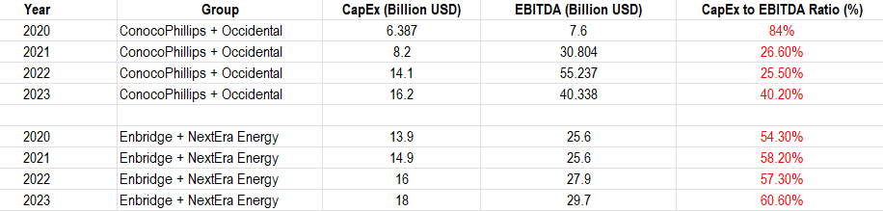
Insights

To explore the relationship between capital expenditures (CapEx) and earnings among oil and gas companies versus renewable energy companies, I selected four companies with similar market capitalizations: Occidental Petroleum (approximately $59 billion), Enbridge ($82.8 billion), ConocoPhillips ($142.7 billion), and NextEra Energy ($147.7 billion).
By combining the data points for Occidental Petroleum and ConocoPhillips into one group, and Enbridge and NextEra Energy into another, I created two distinct comparison groups. The results revealed a clear difference in CapEx and EBITDA (Earnings Before Interest, Taxes, Depreciation, and Amortization). The renewable energy companies (Enbridge and NextEra Energy) exhibited a higher proportion of CapEx relative to their EBITDA compared to the oil and gas companies (Occidental Petroleum and ConocoPhillips). This higher ratio suggests that a significant portion of their earnings is likely being spent on capex or other obligations. Further analysis is needed to determine the specifics. The goal for this section was simply to highlight two metrics of costs vs earnings for the distinct groups.

Assumptions and Limitations
Primary energy consumption remains heavily favored and relied upon worldwide. Although some individual countries have made significant advancements toward achieving their renewable energy goals, they are still far from attaining them. The continued trajectory of GDP growth in these regions will make the transition to renewable energy even more challenging. Many emerging economies were not included in this report, but they will also play a significant role in the future balance of energy consumption.
The market dynamics highlighted in this report represent only a small portion of the overall economic landscape needed to gauge financial metrics between these two energy markets. More detailed analysis in various areas will be required to gain a comprehensive understanding of the overall landscape. Nevertheless, the data provided is still valuable for consideration. The divergence trend for the ETFs extends to almost three years, during which there has been a substantial push for renewable energy utilization and investment. One might expect that the significant resources and marketing directed toward renewables would draw investment away from fossil fuels. However, the ETFs mentioned in this report demonstrate otherwise.
Evaluating CapEx to EBITDA is a fundamental measure of analysis for any company. It provides comparable insights between expenditure and profits. Selecting four companies with similar market caps within each group helped balance any differences or biases in their capacity to acquire and utilize capital. The renewable energy companies covered in this report appear to have a more difficult time reducing costs and increasing earnings. This could be due to factors such as manufacturing, transportation costs, and a lack of overall market interest. The oil and gas industry has a substantial lead in terms of infrastructure, trust, and stability, which helps them reduce costs and generate higher ROIs when compared.
These two energy sources will remain central to global attention for many years to come. It's a battle between necessity, trust, and resiliency versus transition, efficiency, and utilization. Extracting both energy types requires significant financial capital, land, and resources. Continued technological improvements will likely have the biggest impact on shifting the trajectory of either source in a more favorable direction.

Sources

Oil and petroleum products - a statistical overview - Statistics Explained (europa.eu)
Data download (opec.org)
Overview and key findings – World Energy Investment 2023 – Analysis - IEA
BNEF report: US$1.8 trillion of energy transition investment in 2023 (pv-tech.org)
World Energy Investment 2023 – Analysis - IEA
https://www.europarl.europa.eu/RegData/presse/pr_post_story/2022/EN/03A-DV-PRESSE_STO(2022)11-28-58001_EN.pdf

FACT SHEET: How the Inflation Reduction Act’s Tax Incentives Are Ensuring All Americans Benefit from the Growth of the Clean Energy Economy | U.S. Department of the Treasury
Renewable energy statistics 2023 (irena.org)
2022 a record-breaking year for renewable energy in the UK | World Economic Forum (weforum.org)

https://www.energy.gov/sites/default/files/2022-09/USG%20GCEAF%20FACTSHEET_final_1.pdf
FACT SHEET: The President’s Budget Creates Good-Paying Clean Jobs, Cuts Energy Costs, and Delivers on the President’s Ambitious Climate Agenda | The White House
Biden-Harris Administration Delivers Historic Milestones, New Actions for Clean Energy on Public Lands | U.S. Department of the Interior (doi.gov)
New plans to make UK world leader in green energy - GOV.UK (www.gov.uk)
UK's path to net zero set out in landmark strategy - GOV.UK (www.gov.uk)
New laws passed to bolster energy security and deliver net zero - GOV.UK (www.gov.uk)
United Kingdom - Countries & Regions - IEA
Renewable energy | Fact Sheets on the European Union | European Parliament (europa.eu)
Energy and the Green Deal (europa.eu)
Canada needs to accelerate its transition to renewable energy (irpp.org)
Minister Wilkinson Welcomes the Canada Electricity Advisory Council Final Report to Help Build Canada’s Clean Electricity Future - Canada.ca
CER – Canada’s Energy Future 2023: CER’s first long-term Outlook modeling Net-Zero by 2050 (cer-rec.gc.ca)
Canada’s bold policies and support for innovation can underpin a successful energy transition, new IEA policy review says - News - IEA
Oil and petroleum products - a statistical overview - Statistics Explained (europa.eu)
Analysis: Clean energy was top driver of China’s economic growth in 2023 - Carbon Brief
Saudi Green Initiative - (vision2030.gov.sa)
Saudi Arabia announces 300% increase in installed renewables capacity, 43.9 million trees planted since launch of Saudi Green Initiative (greeninitiatives.gov.sa)
pib.gov.in/PressReleaseIframePage.aspx?PRID=1992732
Renewables in Russia – Analysis - IEA

Data Sources
U.S. GDP Per Capita 1960-2024 | MacroTrends
Data download (opec.org)
Ourworldindata
Yahoo Finance - Stock Market Live, Quotes, Business & Finance News

